Luca Guerrieri[1]

April 20, 2016

**Remarks prepared for the workshop “Oil Price Volatility: Causes, Effects, and Policy Implications” to be held at the Council on Foreign Relations on May 5-6, 2016**

Some of my research has focused on the nexus between energy markets and economic activity. Three of my recent papers offer some insights for how different economies react to shocks that move oil prices and why recent declines in oil prices seem to be generating counter-intuitive effects on the U.S. economy. I will start with a baseline case that abstracts from complications that are linked to the monetary policy response and other complications that may stem from the exposure of financial intermediaries to the energy sector. I will then tackle these two important complications in turn.

**What are important determinants of how oil shocks affect different economies across the world?**

This is a question at the center of a paper that I jointly authored with Martin Bodenstein and Chris Erceg.[2] For that analysis we used a stylized multi-country general equilibrium model, and I will be referring to that model and later work that expands on that model to inform my remarks today. Many academic papers have looked at the effects of oil shocks from the perspective of a single country, focusing on the role of oil as input into the production of other goods. These papers ignore that oil is a global commodity, and that fluctuations in oil prices also have repercussion for nonoil trade, which in turn, as our paper shows, are an important component of understand the effects of oil shocks.

One key insight developed by Lutz Kilian and confirmed by our paper and later work with Martin Bodenstein, is that not all oil shocks are alike. In our work we allow for broad sources of fluctuations. We distinguish between oil supply and demand shocks. Oil supply shocks are eerily familiar. One example of an oil efficiency shock stems from breakthroughs in energy efficiency that reduce the demand for gasoline. In general oil demand shocks, affect oil demand directly. Finally, with the price of oil determined endogenously, we also allow for shocks that move aggregate demand and, indirectly, oil demand and prices.

I will focus first on the effects of an unexpected increase in the oil supply abroad. For an oil importer, such as the United States, firms and households increase their oil demand as the oil price decreases. Nonetheless, the oil component of the trade balance improves but this improvement is offset by a deterioration in the nonoil component of the trade balance. This offsetting deterioration is attributable to a positive wealth effect on the oil importer relative to the oil exporter, which induces the importer's nonoil terms of trade to improve, and its nonoil imports to expand. Accordingly, consumption expands, but the response of the overall goods trade balance and GDP is dampened.

Regardless of the specific sources of shocks, we showed that local oil production relative to oil consumption is a key determinant of differences in the responses to the same oil price movement across countries. Though the United States still imports more oil than any other country, the level of local oil production has increased dramatically in recent years, reducing foreign oil dependence and even leading to the lifting of a forty-year ban on the export of U.S. crude oil enacted in response to Arab oil embargo of 1973-1974. According to our results, this reduction in foreign oil dependence tends to buffet the gains associated with lower oil prices for an oil importing country such as the United States.

Foreign oil demand shocks, modeled as shocks that affect the efficiency of oil inputs in consumption, eventually induce similar effects to those of foreign oil supply disturbances. However, their initial dynamics differ substantially. Our estimates indicate that these shocks tend to build up over time and dissipate slowly. An increase in oil efficiency abroad can induce falling oil prices over an extended period as oil efficiency builds up and demand contracts. Since this shock would tend to boost foreign activity disproportionately, the improvement in the nonoil balance is delayed.

Of course, other shocks that influence aggregate demand an oil demand indirectly can also affect the price of oil. To the extent that lower oil prices merely reflect a worsening of the outlook abroad, the expected worsening of the nonoil trade balance can offset the improvements in the oil balance for oil importing countries.

**How does the conduct of monetary policy affect the repercussions of fluctuations in oil prices for the broader economy?**

An important, ongoing debate in macroeconomics concerns the influence of oil shocks on aggregate activity. One view is that oil shocks are a principal source of business cycle fluctuations. In this vein, Jim Hamilton argued that most of the global recession that began in 2008 reflects the preceding run-up in oil prices.[3] In contrast, other researchers of the caliber of Olivier Blanchard and Jordi Galì attributed a small role to oil shocks as drivers of economic fluctuations in the 1980s and 1990s, and suggested an even smaller role in more recent years.[4]

Within this debate, the systematic response of monetary policy to oil shocks plays a prominent role. Bernanke et al. (1997), for instance, argued that a large part of the effect of increases in oil prices in the 1970s can be attributed to tighter monetary policy in response to these shocks. Beginning in 2008, there has been another important systematic change in monetary policy.[5] Namely, in many advanced economies, policy rates reached their zero lower bound, inhibiting their stabilization role.

A key finding of my work with Martin Bodenstein and Christopher Gust is that oil price shocks propagate differently when policy rates are at the zero lower bound. In particular, we show that the zero lower bound constraint tends to cushion rather than amplify the expansion in activity that occurs in response to lower oil prices in normal times when monetary policy is unconstrained by the zero lower bound. We show that the buffeting of the output movement linked to the zero lower bound depends on the source of the shock and on the persistence that alternative shocks induce in the price of oil.

To understand these result, consider the effects of a shock that lowers the demand for oil abroad, pushing down the price of oil in the United States. When monetary policy is unconstrained, this shock tends to push down inflation and boost output in the United States. When policy rates are at the zero lower bound, the lower inflation induced by the shock can lead to higher real rates, exerting downward pressure on the interest-sensitive sectors of the economy, and offsetting the usual expansionary effects of the shock. If the decrease in oil prices occurs gradually enough in response to this shock, it can induce a persistent fall in inflation that might even cause GDP to contract temporarily.

We find that the zero lower bound constraint on nominal interest rates plays a much smaller role in altering the effects of oil supply shocks emanating from abroad. Our estimates indicate that these shocks tend to lead to one-time movements in the price of oil. Accordingly, they do not have a protracted effect on inflation. Hence, the real interest rate is little changed at the zero bound and oil supply shocks have similar effects at the zero bound and in normal times.

**How do chargeoffs on energy loans affect the transmission of oil price declines?**

A drumbeat of reports has pointed to a closer correlation between stock prices and oil prices beyond the mechanical influence of the stocks of energy companies. The large swing in the price of WTI, plummeting to a low of $32.9 in January of this year, down from $60 in January 2015 and $80 in January 2014, surprised observers and market participants. The gyrations in oil prices have led to a spike in the expected defaults of energy companies. Estimates based on data from Moody’s KMV point to one year ahead expectations of defaults for oil firms exceeding 5 percent of the total liabilities of companies with a credit rating.

Banks exposed to the oil sector have been setting aside provisions to cover future chargeoffs, but if oil prices started falling again, what could be the contraction in credit and broader economic activity associated with more severe bank losses? Without reference to supervisory loan data, a recent article in the Wall Street Journal points the way to start quantifying these effects. The article reported $140 billon in unfunded loans and about $80 billion dollars in funded loans, for a total of about 1.5 percent of U.S. GDP. In a paper with Matteo Iacoviello and other co-authors, we developed a suite of models that map capital shortfalls at financial intermediaries into macroeconomic outcomes.[6] Even assuming the chargeoff of the entire amount of loans reported by the Wall Street Journal over the next two years, the rescaling of the more extreme of our estimates for losses totaling 1.5 percent of GDP points to a drop in GDP in the order of 1 percent. This drop stems from the reduced provision of credit as financial institutions attempt to rebuild their capital positions.

In sum, the fall in oil prices over the last two years has been expansionary for the United States, but three factors have contributed to buffeting the gains: 1) lower dependence on oil imports as U.S. supply has expanded, 2) the zero lower bound on nominal interest rates, and 3) the exposure of U.S. financial intermediaries to oil companies.

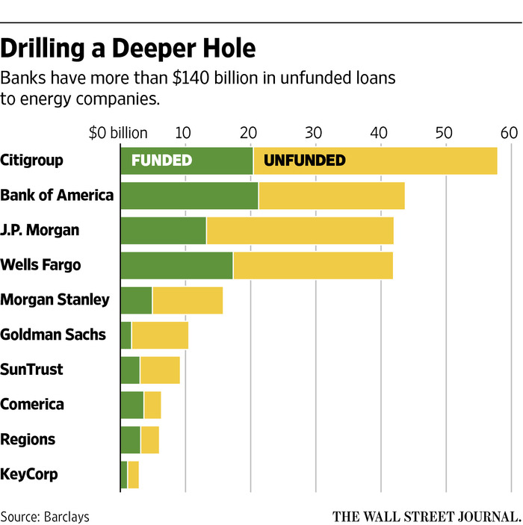

1. The views expressed here are solely the responsibility of the author and should not be interpreted as reflecting the views of the Board of Governors of the Federal Reserve System or of any other person associated with the Federal Reserve System.
2. See "Oil shocks and external adjustment,” with Martin Bodenstein and Christopher Erceg. Journal of International Economics, Elsevier, vol. 83(2), pages 168-184, 2011.
3. Hamilton, J., 2009. Causes and consequences of the oil shock of 2007–08. Brookings Papers on Economic Activity 1, 215–284.
4. Blanchard, O.J., Galì, J., 2007, April. The macroeconomic effects of oil price shocks: Why are the 2000s so different from the 1970s. In: International Dimensions of Monetary Policy, NBER. National Bureau of Economic Research, pp. 373–421.
5. Bernanke, B., M. Gertler, and M. Watson (1997). Systematic Monetary Policy and the Effects of Oil Price Shocks. Brookings Papers on Economics Activity (1), 91{142.
6. See Guerrieri, Iacoviello, Covas, Driscoll, Kiley, Jahan-Parvar, Queraltó, and Sim, 2015. "Macroeconomic Effects of Banking Sector Losses across Structural Models," Finance and Economics Discussion Series 2015-44, Board of Governors of the Federal Reserve System.